Dining Accommodations
NEAIR 2019 Summer Workshops

Coffee:

Please note: Coffee, tea, and water will be available throughout the workshop sessions.

Better Bean (lunch and coffee)
Address: 23 Central Square, Bridgewater, MA 02324
Miles from Campus: 0.4miles
Hours of Operation: 7:00 am to 6:00 pm
Menu: https://betterbeancoffee.com/

Bridgewater Bagel & Coffee
Address: 86 Spring St, Bridgewater, MA 02324
Miles from Campus: 0.3 miles
Hours of Operation: 6:30 am to 1:00 pm
Menu: N/A

Juice Mill
Address: 48 Central Square, Bridgewater, MA 02324
Miles from Campus: 0.4 miles
Hours of Operation: 7:00 am to 4:30 pm
Menu: http://www.juicemillbridgewater.com/

MaryLou’s Coffee
Address: 169 Spring St, Bridgewater, MA 02324
Miles from Campus: 0.1 miles
Hours of Operation: 6:00 am to 9:00 pm
Menu: https://marylous.com/

Lunch Options:

The Bear's Den Cafeteria
Address: Bridgewater State University, Rondileau Campus Center, 19 Park Avenue, Bridgewater, MA 02324
Miles from Campus: *on campus (Menu for the week of July 22 is below)
Hours of Operation: 7:30AM - 5:00PM
Menu: Coming soon

Uncle Shawarama Food Truck
Address: 85 Plymouth St, Bridgewater, MA 02324
Miles from Campus: *on campus
Hours of Operation: 11:00 am to 10:00 pm
Menu: N/A

Barrett’s Ale House
Address: 425 Bedford St, Bridgewater, MA 02324
Miles from Campus: 3.1 miles
Hours of Operation: 11:00 am to 1:00 am
Menu: https://www.barrettsalehousebridgewater.com/assets/files/menus/Food-Menu-2-5-2019.pdf

Chattabox Thai Restaurant
Address: 755 Bedford St # 1, Bridgewater, MA 02324
Miles from Campus: 3.7 miles
Hours of Operation: 11:00 am to 9:30 pm
Menu: http://www.thechattabox.com/

Sugarcane Thai Restaurant
Address: 180 Winter St unit a, Bridgewater, MA 02324
Miles from Campus: 3.7 miles
Hours of Operation: 11:30 am to 9:00 pm
Menu: https://www.sugarcanecuisine.com/menu

Also nearby: D’Angelo, Subway, 99 Restaurant, Papa Gino’s, McDonald’s, Burger King, Taco Bell/KFC, Emma’s Pub & Pizza, Riviera Café Brewhouse
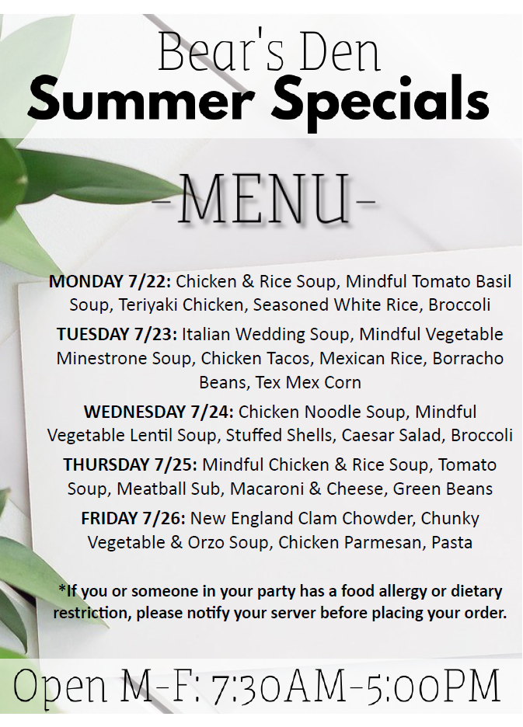
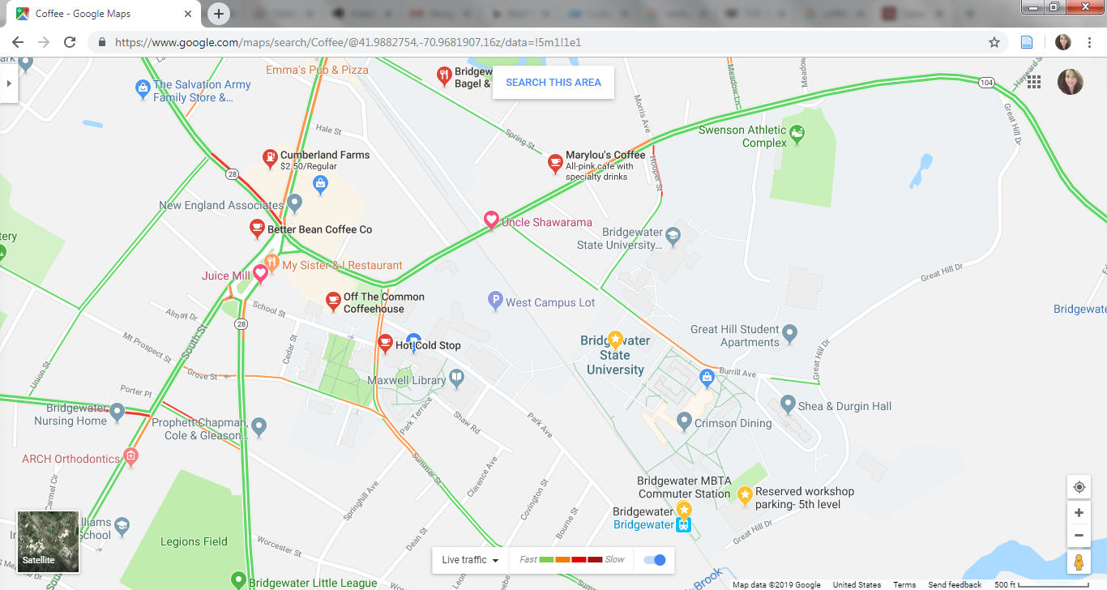
Coffee Map
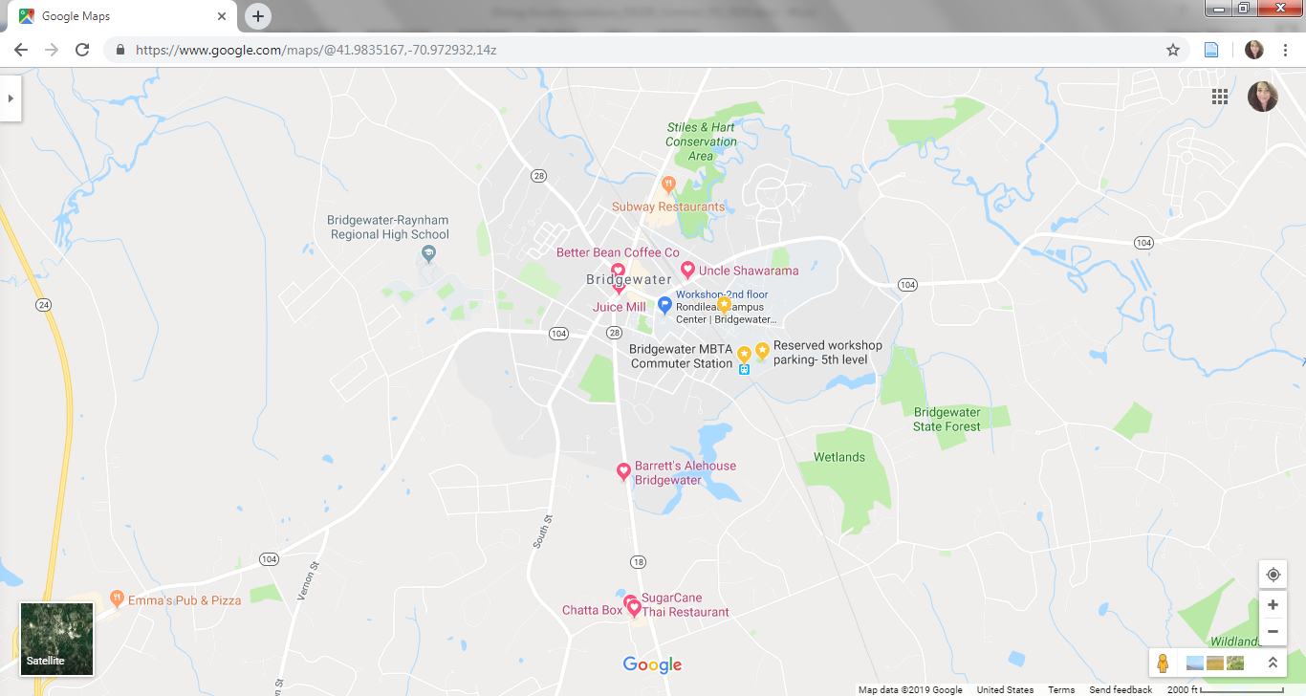
Lunch Map

